**DFS**

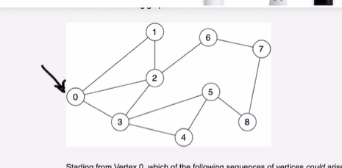

**ADD ‘0’ to the stack.**

**STACK: 0**

**VISITED:**

**Pop ‘0’ from the stack, add ‘0’ to the visited.**

**Add adjacent elements to stack.**

**STACK: 123**

**VISITED: 0**

**Pop ‘3’, mark it as visited.**

**Add adjacent elements to the stack which are ‘4’, ‘5’**

**Since ‘0’ is in visited and ‘2’ is in stack we don’t add them to stack.**

**STACK: 1245**

**VISITED: 03**

**Pop ‘5’, mark visited**

**Add adjacent elements to stack which is ‘8’**

**Since ‘4’ is in stack and ‘3’ is in visited we don’t add them**

**STACK: 1248**

**VISITED: 035**

**Similarly, pop ‘8’ from stack..**

**STACK: 1247**

**VISITED: 03587**

**Similarly,**

**STACK: 1246**

**VISITED: 03587**

**Then,**

**STACK: 124**

**VISITED: 035876**

**Then,**

**STACK: 12**

**VISITED: 0358764**

**Then,**

**STACK: 1**

**VISITED: 03587642**

**Then,**

**STACK:**

**VISITED: 035876421**